Live Better Again

System Overview Report

By Hello IT

Version 1.2

# 

# 

# Table of Contents

**Table of Contents** **1**

**Version Control** **2**

**System Vision** **3**

Project Description 3

System Capabilities 3

Scope 3

Potential Stakeholders 4

Non-Functional Requirements 4

Business Benefits 5

Major Sub-Systems 6

Functional Decomposition 6

Subsystem Descriptions 6

Proposed System Architecture Overview 9

Delivery Cycle Plan 11

**Project Organisation** **1**3

System Development Approach 13

Team Structure 13

Overall Project Plan 13

Risk Management Plan 16

**Sign Off** **1**7

**Appendices** **19**

Development Artifacts 19

Appendix 1: Meeting 01 Minutes 21

Appendix 2: Meeting 02 Minutes 23

# 

# 

# Version Control

|  |  |  |
| --- | --- | --- |
| **Version** | **Date** | **Comments** |
| 1.0 | 24/8/17 | Initial version submitted for Monash IE staff review |
| 1.1 | 25/8/17 | Changes to layout and diagrams based on IE staff feedback |
| 1.2 | 30/8/17 | Further changes based on IE staff feedback |

# 

# System Vision

#### Project Description

Live Better Again is an Australian Company dedicated to providing patients at high-risk of Obstructive Sleep Apnea (OSA) with convenient access to services and a clinical pathway that will help diagnose and treat this serious condition. As a home-operated business, Live Better Again operates with 5 employees (also known as Sleep Technicians) where they are contracted and consult patients at separate locations. After GP referral, the business provides patients with a thorough process from diagnosis to treatment support. Below are the factors that limits the company’s current business process that have lead for a new proposal for an online system. This involves a lengthy holding period of approximately 21 working days. It has been proved that majority of this waiting time is dedicated to incoherent organisation of patient bookings and manual entries of forms where there is not only a great potential for error but also inconsistency between data entries. With a heavy reliance on manual work including excel spreadsheets and handwritten forms, Live Better Again requires automation to streamline numerous processes and ultimately provide a simpler, faster and more secure experience for patients. Live Better Again currently manage their technician bookings through phone where numerous pain points have been identified. As patients are unable to directly contact technicians, LBA plays the role of a middle man which results in inefficient communications. The company requires a registration page which will ease the admin’s workload as well as allow for faster patient response.As a supplier of CPAP machines, a tracking system is also required for purchases and rentals of the machine to ensure supply of stock is always updated and accurate to allow for correct and timely distribution to patients.

The overall goal for this project is to reduce the waiting time for patients from 21 days to a maximum of 7 days.

#### System Capabilities

###### **Scope**

|  |  |  |  |
| --- | --- | --- | --- |
| **People (Stakeholders)** | **Activities** | **Context** | **Technology required** |
| Sleep Technicians | * Register * Login * Generate reports * Manage patient data information * Schedule patient appointments * Register new Patients * Book CPAP device * Invoice purchases of CPAP | Sleep technicians will access a login page which will allow them to register their details and availability through a calendar. They will also be able to access a master form which will collect all patient data information and then generate a PDF form to be uploaded to REMlogic. Should patients not already be pre-registered, technicians will also have the capability to register them. CPAP machines will also be tracked through serial number and technicians can print off invoices. | PC/Tablet/ Smartphone, Scanner, Internet,  Printer, SD Card Reader  Software:  Web Browser |
| Administrators | * Register * Login * Sell CPAP machines * Check technician availability * Book appointment with technician | Administrators will be able to register themselves as admins. They will be able to view technician availabilities and book appointments for patients. Some administrators might also be sleep technicians. A CPAP tracking system will also be present for them to monitor and order more if stock is falling behind. | As above |
| Patients | * Book appointments online **(additional functionality)** * Electronic consent forms **(additional functionality)** * Electronic patient details **(additional functionality)** | Patients will be able to access calendars through the website. When booking appointments they will have access to the master form and will be able to fill out details accordingly. | PC/Tablet/ Smartphone, Internet  Software: Web Browser |

###### **Potential Stakeholders**

|  |  |  |  |
| --- | --- | --- | --- |
| **People (Stakeholders)** | **Activities** | **Context** | **Technology required** |
| GPs | Login and access files | General Practitioners have an option to check on a patient | PC |
| Scorer | Pull patient’s record from files, edit it and saves it | Scorers have an option to retrieve records saved and input additional information | TBC |
| Sleep Physicians | Sign off documents received by sleep technicians | TBC | TBC |

###### **Non-Functional Requirements**

|  |  |
| --- | --- |
| **Requirement** | **Description** |
| Security | The implemented system should always be secure to protect the privacy of company’s data as well as patient’s information. |
| Data Integrity | Data should ensure consistency and accuracy through implementation of restricted data input. |
| Reliability | The system should contain minimal to zero errors which will cause runtime errors or crash when used by multiple users. |
| Performance | Any updates to patient data should reflect on all ends of the system immediately to ensure that business process can operate as smooth and as timely as possible. |

#### 

#### Business Benefits

1. **Increased capacity to treat more patients**

This will be a direct result from the overall goal of reduced patient holding time as technicians will be able to receive patient information and produce patient treatment plans at a faster rate, increasing the capacity to take on and treat more patients.

**2. Decrease in labour costs**

Current administrator work is expected to be automated through online forms and booking systems. This will reduce the labour costs involved in maintaining and hiring an administrator.

**3. Secure storage of patient data**

Central storage of patient data will reduce potential of security breaches that is currently present as data is sent over different servers.

**4. Easy access to information**

This automated system will enable sleep technicians to easily access patient information online through the database instead of looking through files manually which in turn saves time as well

System Requirements

#### Major Sub-Systems

##### Functional Decomposition

##### Subsystem Descriptions

1. **User Registration**

The registration subsystem is responsible for account management of all end users. This will handle the creation of new user accounts for administrators and sleep technicians, assign these accounts to a ‘known’ administrator or sleep technician in the database, and define the permissions that each type of account has (what they can view, what they can edit and so on).

As requested, the scope is currently limited to accounts for administrators and sleep technicians, and all associated functionality that they will require and be entitled to under this design.

*1.1 & 1.2 Register sales technician or administrator*

This provides the ability for the creation of accounts for sleep technicians and administrators, and match them to a database record if appropriate.

*1.3 Manage account types*

To provide scalability, this function allows for the creation and removal of different account types eg. for GPs, patients and scorers, that may need to be added at a later date. The ability is also provided to add and remove permissions for each activity (view, create, edit etc.) for each function of the system, providing granular control that can be modified as business needs change.

Please note that permissions control will be limited to the activities that are within the scope of this project, and would need to be modified at the code level to encompass any future modifications to the system.

1. **Patient Registration**

The patient registration subsystem has a focus on the initial referral and recording of the patient’s information upon their first visit. At this stage of the process, all the paperwork is prepared and completed, as required by Live Better Again and by the relevant government agencies (eg. Medicare).

*2.1 Collect Patient Information*

A master form will be presented for technicians to collect all personal details and other relevant data from a patient upon their referral. This information will be stored securely within LBA’s records, and be used to populate the personal details form, consent form, ESS form and Medicare form.

*2.2 Collect Patient Consent*

A patient is required to consent to tests and authorise Medicare claims (and other Medicare activities). This function is responsible for displaying a page that will be used to collect the patient’s informed consent and their signature, which will be applied to the aforementioned forms.

It should be noted that the implementation of this function will be limited by the business decision to not purchase any additional hardware for signature collection.

*2.3 Generate Medicare forms*

Using the data from the other functions of this system, the Medicare papers will be generated within the system.

1. **CPAP Tracking**

LBA loans a number of CPAP devices to use for home sleep tests. In order to determine availability and locate a potentially missing device, tracking functions will be implemented to manage the state of each CPAP device.

*3.1 Identify assigned technician*

Each device is assigned to a technician, who has the right to loan it out to their patients as required. This function will be able to determine which technician is responsible for a given device.

*3.2 Identify assigned patient*

Devices will be regularly loaned to patients for testing. This function will allow for the identification of the patient who has each device at a given point in time, and also when it is expected to be returned.

*3.3 Allocate device*

In order to provide the above functionality, devices need to be allocated to technicians and patients as relevant. This function will both serve to assign the device to a technician upon its purchase, and, subject to checking the available devices, assign a device to a patient to take home.

1. **Appointments**

Each LBA clinic needs to be able to manage its technicians’ time and effortlessly take appointments from new and returning patients. As such, the appointment subsystem will provide calendar-like functionality, where times can be booked for patients, and a technician’s schedule is available.

*4.1 Create Appointment*

An administrator will be able to instantly book and confirm an appointment time for a patient, either by checking whether a patient’s preferred time is available, or by suggesting available times for a given technician within a given period. This function will also allow for the selection of a preferred technician for the appointment, or on an allocation basis.

*4.2 View Schedule*

To facilitate the appointment making process, or for other uses, the ability will be present for administrators (and other permitted accounts) to view each sleep technician’s availability, in either a free/busy format or with details, depending on permission.

1. **Patient Management**

A returning patient is subject to assessments and treatments to monitor and address their condition. Key metrics such as ESS and BMI are tracked for each visit, and a patient history must be maintained for both regulative reasons as well as for technician reference.

*5.1 Record Patient Data*

Patient metrics, such as ESS and BMI, can be entered upon their measurement at (or prior to) each appointment, in order to enable the tracking and trending of these metrics over time and provide insights to the technicians.

*5.1 Record Patient Treatments*

During or following each appointment, a technician can input their comments, any tests given and any treatments prescribed to a patient, which can be recalled at a later time for reference.

1. **Invoicing and Reporting**

This subsystem provides record keeping functionality and insights to the greater system. The tracking of financial activity, which for this build is currently limited only to the sale of CPAP devices to patients with severe cases of sleep apnea, will be used to generate invoices for sales and be of further use for reconciliation and financial reporting/tax. This module will also provide reporting functionality for all data contained within the system, be it financial, medical or otherwise, and transform it into meaningful reports and graphs.

*6.1 Generate clinic reports*

Reports will be generated as per the business needs of LBA. At this time, the scope of reports is limited to those generated from medical data and patient tests, and includes:

* List of reports
* List of reports
* List of reports

*6.2 Generate CPAP sale invoice*

Upon the sale of a CPAP device to a diagnosed customer, an invoice can be raised within the system, tracking the sale of the device to that particular patient, and in turn process and/or record the proceeds from that transaction upon their receipt.

The invoice function will also be future-proof, to provide the ability for LBA to expand its utility and use it for the issue of any good or service, but at this time the focus is only on the CPAP sales.

Conceptual Data Model (Entity Relationship Model)

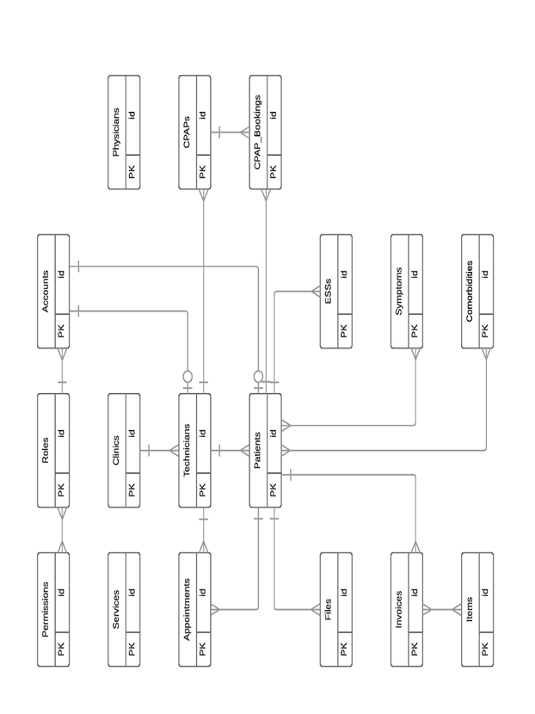

#### 

#### Proposed System Architecture Overview

**Existing System**

The company Live Better Again, also trading as Sleep Better Again currently has a manually intensive business workflow. Most of the processing still involves paper based data entry and some of it, from the information the team has gathered is not recorded at all. The proposed system will be primarily focused on the process immediately after the business receives the referral fax/mail from the General Practitioner. At this moment, the current business process involves:

An available sleep technician: -

* Creating a manual entry of the patient’s details to a paper based form
* Further manual entry of the patient’s details to a paper based Medicare form.
* Manual entry of patient’s preliminary assessment to a paper based Epworth Sleepiness Scale form.
* Receives the completed and signed paper based consent form from the patient.
* Sources and allocates a patient a CPAP device and some record of the transaction recorded into a spreadsheet (still to be sourced from the client).
* Collates said forms and scanning them to pdf files.
* Extracts CPAP device raw data and entered into Remlogic software to be analysed.
* Compresses PDF files and CPAP data report into a zip folder.
* Uploads the zipped folder to the business’ Amazon Cloud account.
* Stores the physical forms into actual folders and stored in boxes located in the premise.

Once a patient’s zipped folder is uploaded, a sleep scorer is notified of the data of the new/existing patient to be analysed. The scorer then analyses the patient data and produces a report and uploads the report into the patient’s zipped folder in the Amazon Cloud.

The scored report is then printed out and given to the sleep physician who will review the report, sign it and prepares it to be sent back to the GP via fax/mail.

*Diagram a. Current system diagram. Live/Sleep Better Again.*

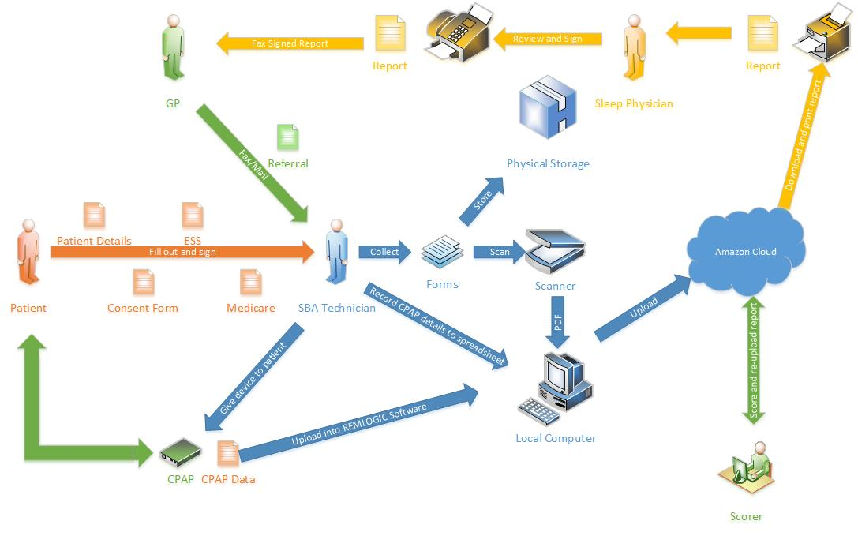

**Proposed System**

After intensive analysis of the company’s business processes, the Hello IT team has come up with the solution in improving those business processes. The client has iterated that automating the majority of the business processes is the major feature that is paramount with the project. The team has realised that the client required four major non-functional features of the new system. This includes:

* Security. Due to the sensitive information being recorded by the proposed system, as well as the client having to comply with certain Australian laws with regards to data retention, data security is paramount to its successful implementation.

* Data Integrity. In conjunction with data security, the proposed system will ensure that data being recorded has cohesion giving it the ability to be reused multiple times without risk of it being corrupted.

* Reliability. The proposed system will be reliable by utilising an industry standard database as its backbone. Not only will the database ensure data integrity, it also has the added benefit of being integrated with other systems in the future.

* Performance. Since the proposed system is database based, its performance can be quantified and improved upon through rigorous testing and subsequent iterations.

*Diagram b. Proposed system architecture. Hello IT.*

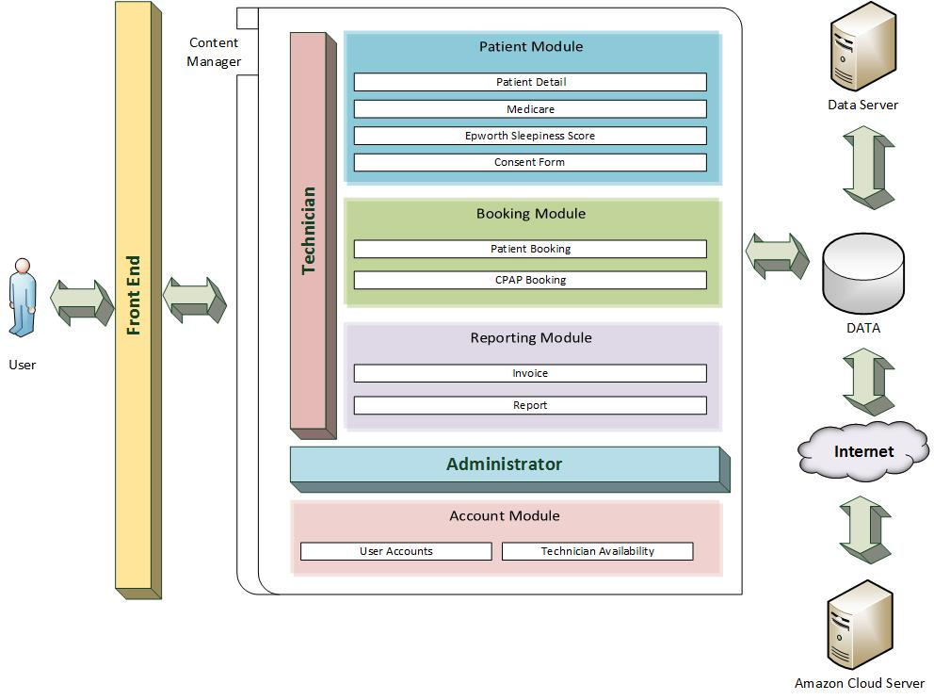

As can be clearly observed through the diagrams, the proposed system streamlines the majority of the business processes currently in use, in particular, the process a technician performs when entering patient data is extensively simplified. The proposed system will be using the CakePHP framework.

#### Delivery Cycle Plan

|  |  |  |  |
| --- | --- | --- | --- |
| Iteration 1 | Implementation of account registration for admins and sleep technicians | High | 20th September 2017 |
| Master form to collect all patient data information | High |
| Facility to electronically sign consent forms | High |
| CPAP – Inventory Management, serial number assignment | Medium |
| Iteration 2 | CPAP – Patient tracking, booking | High | 18th October 2017 |
| Technician appointment booking | Medium |
| Invoicing and receipting of purchases of CPAP machines | Low |
| Website upgrade | Low |
| Iteration 3 | TBC | TBC |  |
| Iteration 4 | TBC | TBC |  |

# Project Organisation

#### System Development Approach

This project will utilise the agile development approach where functionalities are built in iterations. After each iteration, the new functionality will be implemented and tested followed by user feedback. Should there be any changes necessary, the team will work towards improving and implementing these changes until the user is satisfied with the product.

The project has identified 4 necessary iterations in addition to an initial Build 0, where a clean installation of CakePHP will be deployed.

#### Team Structure

|  |  |  |
| --- | --- | --- |
| **Name** | **Role** | **Email** |
| Allison Tang | Project Leader/Builder | atan110@student.monash.edu |
| Francis Nacional | Client Liaison/Builder | fnac2@student.monash.edu |
| Bryan Sim | Builder | bssim5@student.monash.edu |
| Joshua Brown | Builder | jdbro12@student.monash.edu |
| Trista Li | Builder | lli254@student.monash.edu |

NB: Builders actively engage in all aspects of the development and implementation process

#### 

#### 

#### 

#### 

#### 

#### 

#### 

#### 

#### Overall Project Plan

Gantt chart

|  |  |  |  |  |
| --- | --- | --- | --- | --- |
| Task Name | Duration | Start | Finish | Predecessors |
| **0.0 Live Better Again Project** | **70 days** | **Fri 28/07/17** | **Thu 26/10/17** |  |
| **1.0 Build 0** | **12 days** | **Fri 28/07/17** | **Sun 13/08/17** |  |
| 1.1 Configure project development team | 6 days | Fri 28/07/17 | Fri 4/08/17 |  |
| 1.2 Setup development environment | 11 days | Fri 28/07/17 | Sun 13/08/17 |  |
| **2.0 Iteration 1** | **33 days** | **Mon 14/08/17** | **Wed 20/09/17** | **2** |
| 2.1 Define requirements | 12 days | Mon 14/08/17 | Sun 27/08/17 |  |
| 2.2 Define specific functionalities | 10 days | Wed 16/08/17 | Sun 27/08/17 |  |
| 2.3 Create risk assessment | 2 days | Sat 26/08/17 | Sun 27/08/17 |  |
| **2.4 System design** | **5 days** | **Sun 27/08/17** | **Fri 1/09/17** | **7** |
| 2.4.1 UI development | 6 days | Sun 27/08/17 | Fri 1/09/17 |  |
| 2.4.2 Design ER diagram | 6 days | Sun 27/08/17 | Fri 1/09/17 |  |
| 2.4.3 Database implementation | 6 days | Sun 27/08/17 | Fri 1/09/17 |  |
| **2.5 System development** | **17 days** | **Fri 1/09/17** | **Wed 20/09/17** |  |
| 2.5.1 Build CPAP booking sub-system | 11 days | Sat 2/09/17 | Thu 14/09/17 |  |
| 2.5.2 Build user registration sub-system | 11 days | Sun 3/09/17 | Fri 15/09/17 |  |
| 2.5.3 Build patient registration sub-system | 11 days | Sun 3/09/17 | Fri 15/09/17 |  |
| 2.5.4 Build CPAP tracking sub-system | 11 days | Sat 2/09/17 | Thu 14/09/17 |  |
| **2.6 Testing** | **17 days** | **Fri 1/09/17** | **Wed 20/09/17** |  |
| 2.6.1 Create testing plan | 2 days | Sat 2/09/17 | Sun 3/09/17 |  |
| 2.6.2 Test CPAP booking sub-system | 17 days | Fri 1/09/17 | Wed 20/09/17 |  |
| 2.6.3 Test user registration sub-system | 17 days | Fri 1/09/17 | Wed 20/09/17 |  |
| 2.6.4 Test patient registration sub-system | 17 days | Fri 1/09/17 | Wed 20/09/17 |  |
| 2.6.5 Test CPAP tracking sub-system | 17 days | Fri 1/09/17 | Wed 20/09/17 |  |
| **3.0 Iteration 2** | **26 days** | **Thu 21/09/17** | **Thu 26/10/17** | **5** |
| 3.1 Discuss further requirements | 6 days | Thu 21/09/17 | Thu 28/09/17 |  |
| **3.2 System development** | **12 days** | **Thu 21/09/17** | **Fri 6/10/17** |  |
| 3.2.1 Build invoicing and receipting sub-system | 12 days | Thu 21/09/17 | Fri 6/10/17 |  |
| 3.3 Test invoicing and receipting sub-system | 12 days | Thu 21/09/17 | Fri 6/10/17 |  |
| 3.4 Upgrade website | 15 days | Sat 7/10/17 | Thu 26/10/17 |  |
| 4.0 Iteration 3 | 15 days | Mon 20/11/17 | Fri 8/12/17 | 24 |
| 5.0 Iteration 4 | 16 days | Mon 8/01/18 | Mon 29/01/18 | 30 |
| 6.0 Rollout | 1 day | Tue 30/01/18 | Tue 30/01/18 | 31 |

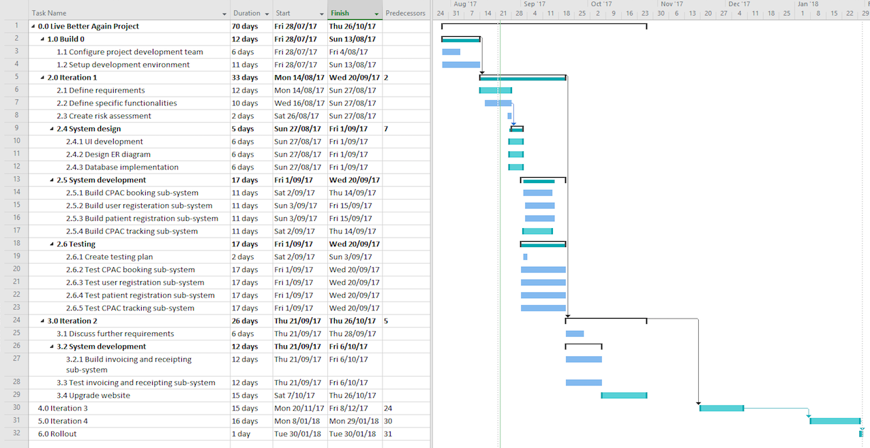

#### Risk Management Plan

|  |  |  |  |  |  |  |
| --- | --- | --- | --- | --- | --- | --- |
| **Risk ID** | **Risk Description** | **Consequence** | **Likelihood** | **Rank** | **Strategy** | **Strategy Description** |
| 1 | Patient Privacy Concerns | Major | Moderate | High Risk | Control | Encryption required of data in transit and data in storage.Potential breach of patient privacy information as data is distributed across multiple servers and locations, and could provide opportunity for misplaced data. |
| 2 | Technician resistance to newly implemented system. | Minor | Moderate | Medium Risk | Control | In house demonstration of new system and/or training required.  This risk will prove to be difficult to control as technicians are not central to one location, rather spread out across the state. Also, large change expected as current systems involve manual entries. |
| 3 | Integration failure with current system | Minor | Moderate | Medium Risk | Control | Attempt integration at iterations to ensure success prior to completion of whole system. |

# 

# Sign Off

I _____________________ have reviewed the System Overview Report by Hello IT and hereby conditionally fully accept the scope, content and expectations laid within. I will detail any conditions to my acceptance to this report in the space provided below. I also acknowledge and understand that there may be changes throughout the iterative development process. Should these changes occur, I agree to providing timely feedback.

Please detail conditional acceptance:

________________________________________________________________

________________________________________________________________

________________________________________________________________

________________________________________________________________

________________________________________________________________

________________________________________________________________

Signed:

Full name: ________________

Signature: ________________

Date: __/__/__

# 

# 

# Appendices

#### Development Artifacts

**Business Process Sketch**

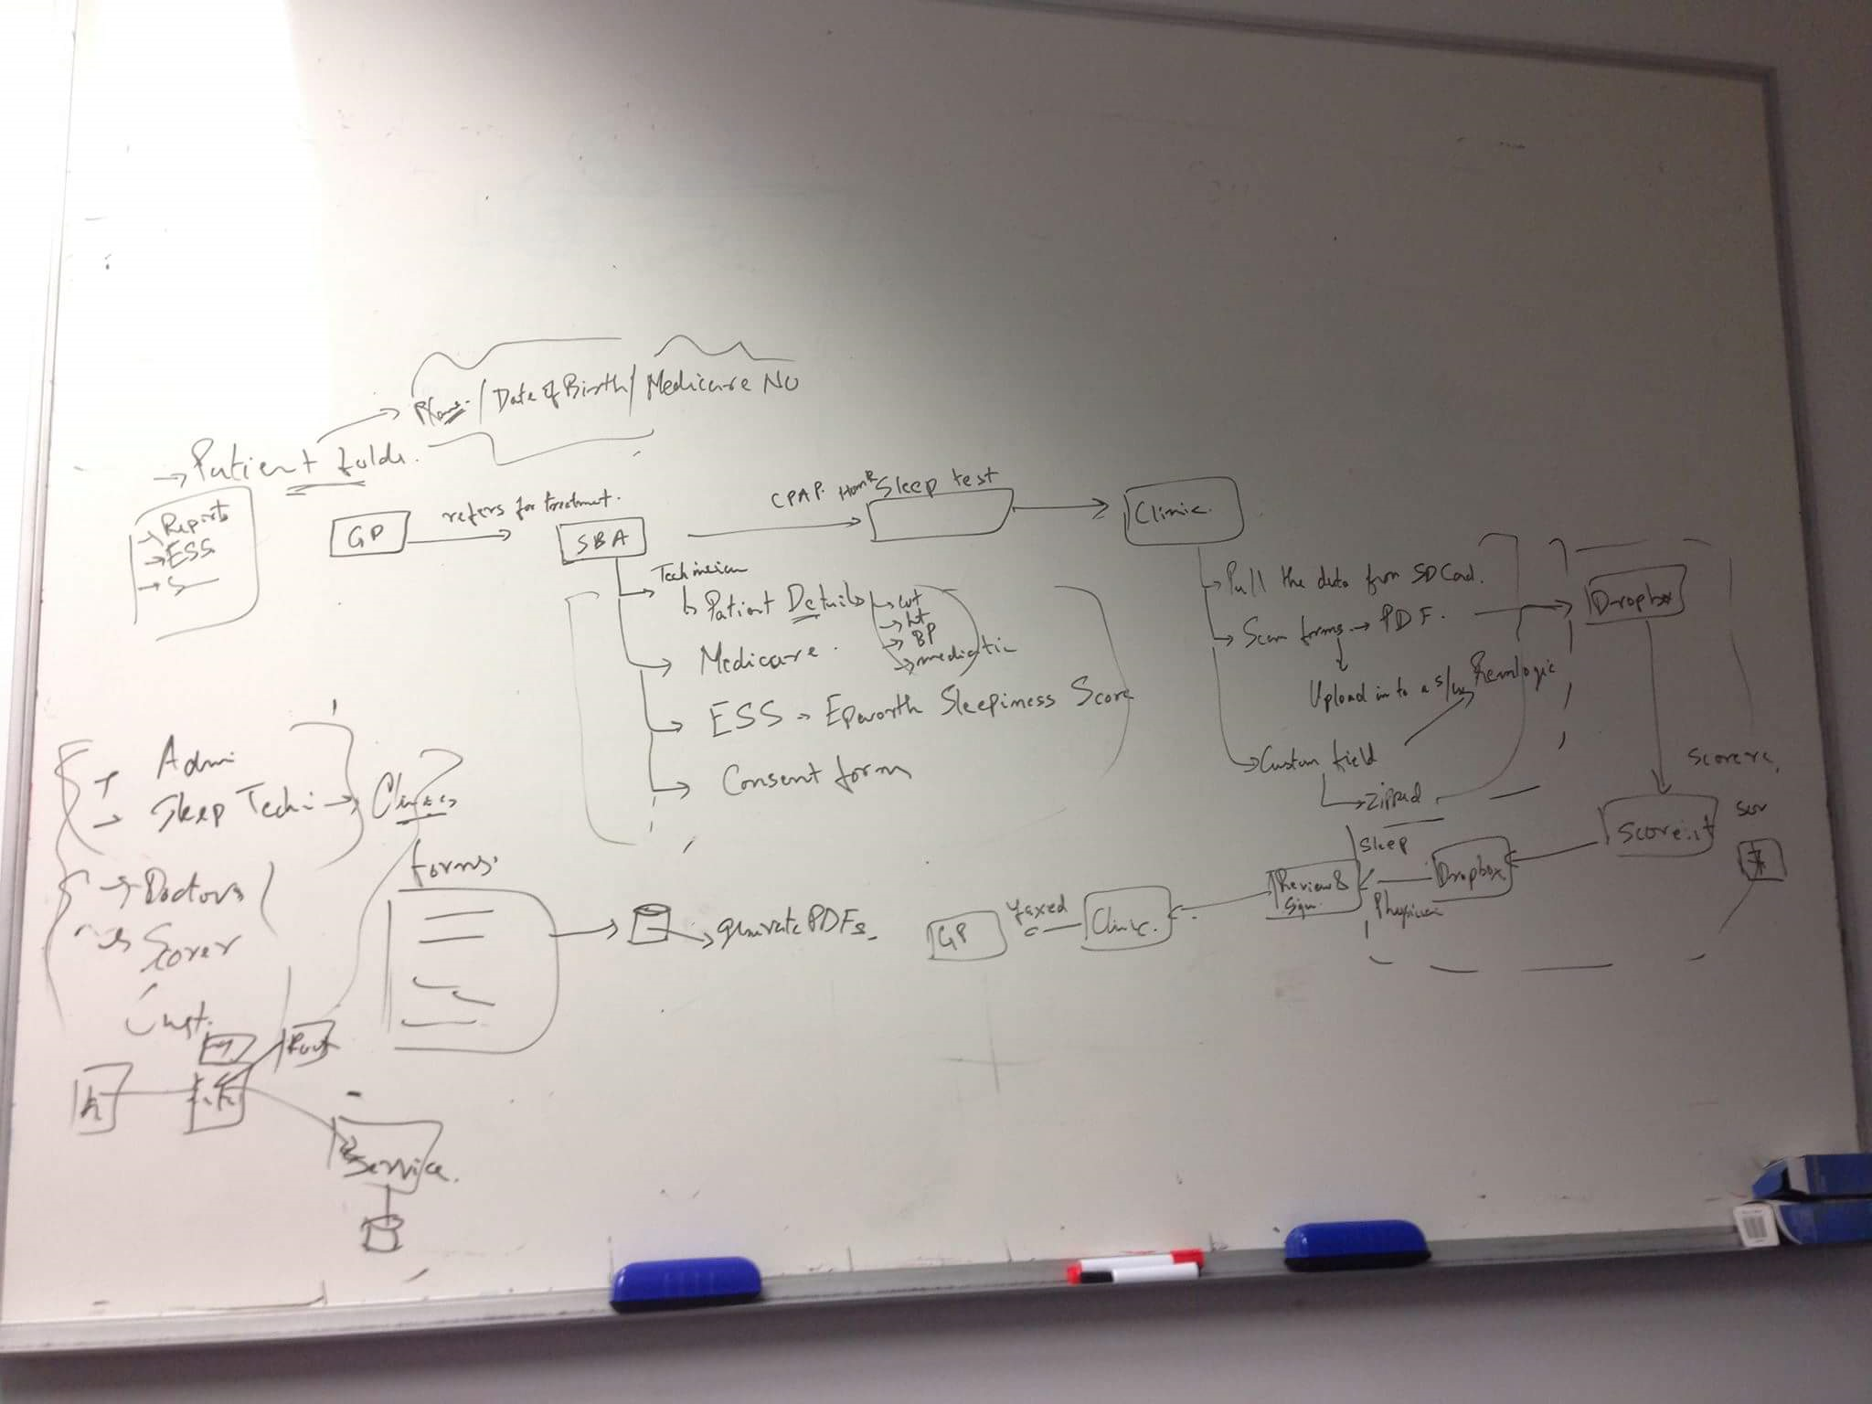

**User stories**

1. As an administrator, I want to be able to view personal details of GP, receptionists, technicians and physicians working in each clinic, so that I can manage the clinic more effectively.

2. As an administrator, I want to add personal details of new receptionist, technician physician and GP to the system, so that I can know how many staff do we currently have in each clinic and contact with them easier.

3. As an administrator, I want to be able to add a new clinic which gets associated with us to the system, so that I can manage all clinics on a single platform.

4. As an administrator, I want to be able to view technician’s availability, so that I can book in their schedule.

5. As an administrator, I want to view and track CPAP booking details, so I can manage the usage of CPAP devices easier.

6. As an technician, I want to use calendar system to make a booking if someone calls or walks into the clinic, so that I have a record of all bookings.

7. As an technician, I want to be able to register new patient to the system, so that I can contact with he/she and keep track of his/ her treatment history more convenient.

8. As an technician, I want to be able to generate invoice for patients, so that we can charge them.

9. As an technician, I want to book CPAP device on the system, so I can ensure there’s available device when providing treatment for my patients.

#### Appendix 1: Meeting 01 Minutes

|  |  |  |  |
| --- | --- | --- | --- |
| Minutes | August 11, 2017 | 5:00 pm – 7:00 PM | K1.16, Monash University Caulfield Campus |

|  |  |
| --- | --- |
| **Type of meeting** | Introductory Meeting |
| **Note taker** | Joshua Brown & Allison Tang |
| **Present** | **Hello IT:**  Allison Tang, Joshua Brown, Lingxiao Li, Bryan Sim, Francis Nacional  **Live Better Again:** Dishit Devasia |
| **Apologies** | None |
| **Absent** | None |

## Agenda topics

|  |
| --- |
| Delivery Schedule & Timeline |

|  |
| --- |
| **Discussion** |
| Dishit would like more frequent delivery of code, which will be deployed onto their Amazon Cloud for testing and for providing more timely feedback. More frequent delivery was discussed with a Monash mentor (Harnam) and there is no reason why this cannot be done.  Dishit has also advised that he will be on holiday between October 23 – 17 November, which is conveniently during the Monash exam period and should cause minimal disruption. |

|  |  |
| --- | --- |
| Discussion of project & Brief |  |

|  |  |  |
| --- | --- | --- |
| **Discussion** | | |
| Live Better Again (LBA) has explained that the project involves the automation of various processes in various defined modules. The current system used by LBA has a lot of data duplication, and storage of data is spread across multiple locations (with some of it retained in archive boxes in paper file).  While each module is currently stable, the role of the student team will be to integrate this modules into a single platform that can be used across multiple clinics by their sleep technicians. For example, by typing in a patient’s name, all relevant data can be retrieved and displayed.  Dishit intends to provide more low-level detail than is specified in the project brief. This information is yet to be prepared. The student team raised that they are required to have a project specification prepared for review prior to Friday, and that this information is required ASAP – ideally at the next meeting, which will be planned today.  Dishit has also expressed an interest in having appropriate design documentation prepared, to allow for future maintenance and support of the system, and to facilitate further development.  The possibility was also discussed about updating their existing website, as it has been unchanged since it was designed by a group of IE students in the past. The student team is unsure about whether there will be sufficient time to undertake this as well. This will be further discussed upon receiving more detailed requirements for the client management system. | | |
| **Action items** | **Person responsible** | **Deadline** |
| Preparation of low-level project requirements | Dishit |  |

|  |  |
| --- | --- |
| Prioritisation of project requirements |  |

|  |  |  |
| --- | --- | --- |
| **Discussion** | | |
| Project priorities are not yet possible to discuss. Dishit will take priotieis into account when preparing the low-level requirements described above.  LBA has enquired into whether the student team’s approach will involve each person working on multiple modules in parallel, or whether the entire team will collaborate on one module at a time. This will be discussed by the team with Dishit at a future time, once we are more aware of the requirements. | | |
| Security and privacy requirements |  |

|  |
| --- |
| **Discussion** |
| Data is required to be encrypted in transit and in storage. This will need to be a consideration made during the development process. Further discussion on this matter will likely follow at a later date. |

|  |  |
| --- | --- |
| Next meeting |  |

|  |
| --- |
| **Discussion** |
| Due to his full-time work commitments, Dishit is unable to meet with the student team during ordinary working hours. A preference was expressed to have meetings on Saturdays in the future.  For the second meeting, a list of predefined times was supplied by the Monash mentors to students, with most available times being on Tuesday & Wednesday. A time was selected (Tuesday 6pm), which is outside of business hours, and allows the student team to meet their deliverable review requirements of that week.  Dishit also suggested the creation of a Slack channel for queries, sending documents etc. |

|  |  |
| --- | --- |
| **Next Meeting** | Tuesday 15 August, 6pm – 7pm in K6.09, Monash University Clayton Campus |

#### 

#### 

#### Appendix 2: Meeting 02 Minutes

|  |  |  |  |
| --- | --- | --- | --- |
| Minutes | August 15, 2017 | 6 PM – 7 PM | K6.97, Monash University Caulfield Campus |

|  |  |
| --- | --- |
| **Type of meeting** | Ordinary Meeting |
| **Note taker** | Joshua Brown |
| **Present** | **Hello IT:**  Allison Tang, Joshua Brown, Lingxiao Li, Bryan Sim, Francis Nacional  **Live Better Again:** Dishit Devasia |
| **OBSERVERS** | Livia Mammarella |

## Agenda topics

|  |
| --- |
| Further Discussion of current System |

|  |
| --- |
| **Discussion** |
| Dishit gave the student team an overview of the current system, using the whiteboard to illustrate the data flow.    The data flow is, roughly, as follows:   1. Patient is referred by GP 2. Technicians register patient details prior to sessions 3. Patients complete forms – Medicare, ESS, consent 4. Clients are given a CPAP machine which records sleep data at home, to an SD card 5. The machine data is extracted from the SD card by a technician and imported into Remlogic software 6. Patient forms are added to Remlogic, and data added as custom fields 7. Remlogic data is combined, zipped and uploaded to an online “drop box” 8. The data is accessed by scorer, who score the data and sort the data (folders) 9. Sleep technicians review the raw data, and Remlogic-generated reports, prior to preparing and signing their own report 10. This information is returned to the clinic by fax, where the diagnosis is passed along to the patient’s GP.   Outside of this existing process, Sleep Better Again also undertakes the following related activities:   * Sale of CPAP machines to patients with severe cases of sleep apnea |

|  |
| --- |
| Project Requirements |

|  |  |  |
| --- | --- | --- |
| **Discussion** | | |
| Dishit outlined that the main problem in the current business process is the time and duplication from filling out and inputting data from multiple forms. It is expected that the student team prepare a solution containing the following:   * A master form which will collect all patient data information, to store in a database and create a pdf (or equivalent format) to be stored in Remlogic * As part of the master form, a facility to electronically sign consent forms eg. Using a mouse * The implementation of user registration for admins and sleep technicians, with capabilities to potentially be added for doctors (GPs) and scorers at a later stage. * CPAP machine tracking, which can be used to identify which technician is in control of the machine, whether the technician has sent it out with a patient, and if so, which patient has it at the current time. * Technician booking, where staff are able to see a technician’s availability and book appointments in their schedules (this is currently done by contacting each technician over the phone). This could be potentially opened up in the future to allow customers to book appointments online. * Invoicing and receipting of purchases of CPAP machines when sold to a client with a severe case. Future expansion will also entail the invoicing of the distributor of the machines. * Report generation, providing insights per-technician and per-clinic   Dishit also further explained his request for design documentation. This mostly involved the creation of UML documents, outlining the interaction between layers for a function. This documentation is likely to be prepared throughout the regular course of development anyway, and all documentation and development artifacts will be handed over upon the completion of the project.  There is also the possibility to upgrade and integrate with the Sleep Better Again website, which is currently static and limited. | | |
| **Conclusions** | | |
| The requirements currently outlined are too few for four iterations, and further functionality will need to be requested during the project. Dishit will request further requirements upon reviewing our progress and output, with a rough target set for the first two weeks of September. | | |
| **Action items** | **Person responsible** | **Deadline** |
| CPAP booking spreadsheet template to be sent to students | Dishit |  |
| Other sample data/spreadsheets to be sent to spreadsheets once it has been cleaned/anonymised | Dishit |  |
| Students to prepare a build of the described functions for review | Hello IT | September |

|  |
| --- |
| Prioritisation of Project Requirements |

|  |
| --- |
| **Discussion** |
| Dishit has indicated that the user registration function and master form function are of the highest priority right now. Further functions will be prioritized in the future. |

|  |  |
| --- | --- |
| **Next Meeting** | To be discussed – expected for Saturday 26 August at a time TBA |